If we add multiple HDD in RHEL, and try to start system, it look for DHCP for network boot. It is shown as-

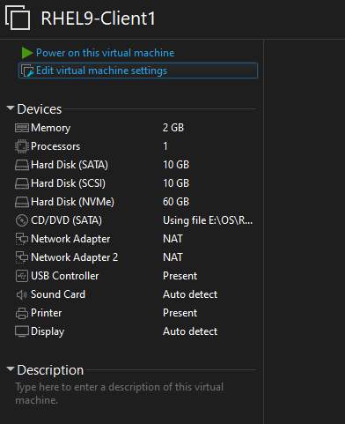

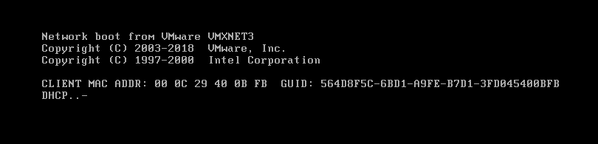

If we get this screen, the possible reason: It is not getting booting drive. To resolve this, we need to check for our bootable hard disk in VMWare disk list. For my case, bootable drive is NVME type as shown below-

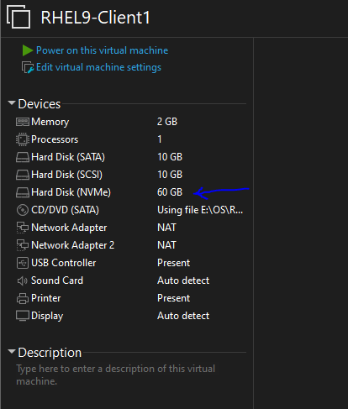

To resolve this, we need to keep this drive at top in BIOS boot device setting, as shown below-

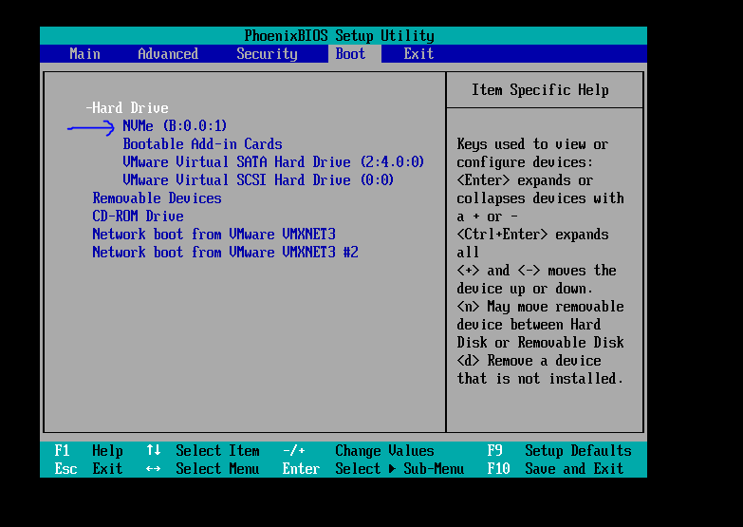

Now we will see RHEL kernel images during boot-

